**COMPUTER SYSTEMS AND PROGRAMING**

**(Home Assignment-4)**

**NAME:** SAMEEN WASEEM

**BATCH:** ME-15

**SECTION:** A

**CMS ID:** 465064

**SUBMITTED TO:**

**COURSE INSTRUCTOR:** DR MUHAMMAD JAWAD KHAN

**LAB INSTRUCTOR:** SIR SAQIB



**CODE # 1:** Total number of populations in Punjab, Sindh, KPK, and Balochistan using a switch case.

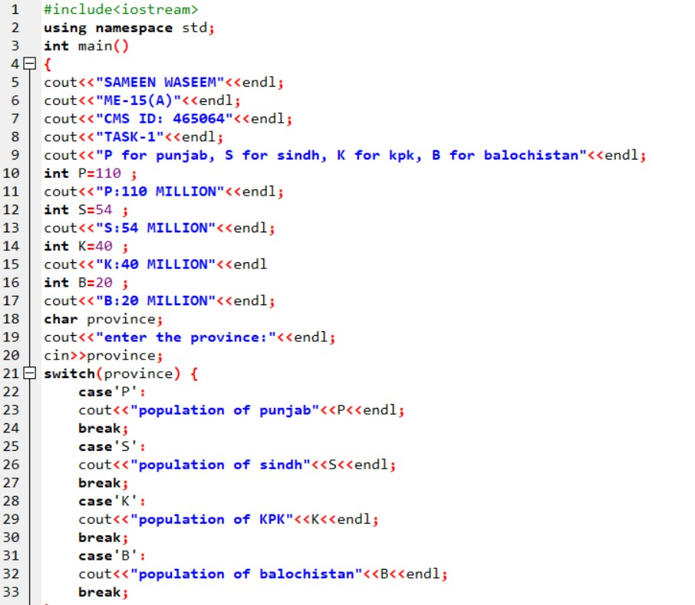

**OUTPUT:**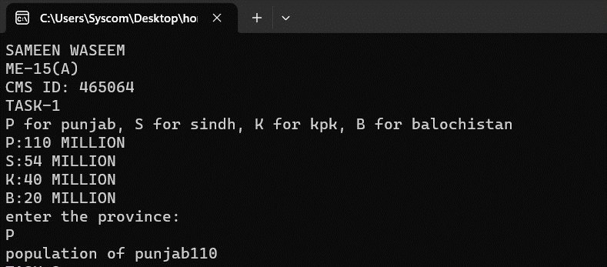

**CODE # 2:** Write a C++ program to check whether an alphabet is a vowel or consonant using a switch case.

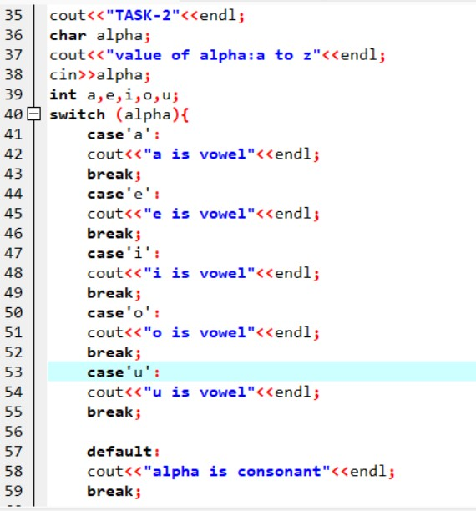

**OUTPUT:**

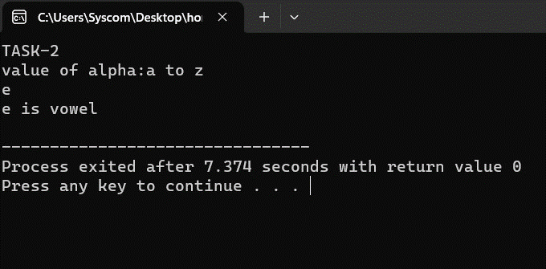

**CODE # 3:** Write a C++ program to check whether a number is positive, negative, or zero using a switch case.

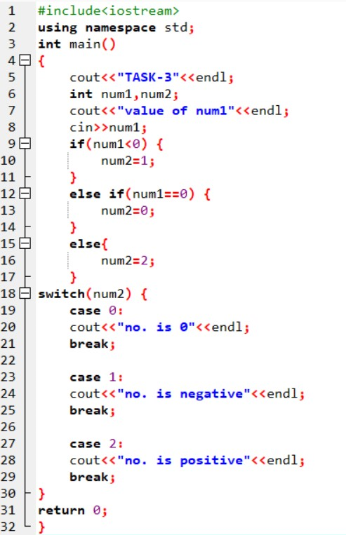

**OUTPUT:**

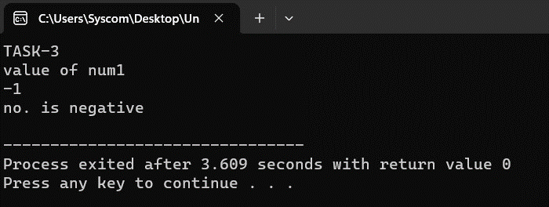

**CODE # 4:** Write a C++ to find out whether a person is an adult, teenager, or child using nested if-else.

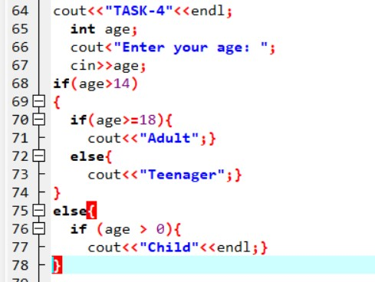

**OUTPUT:**

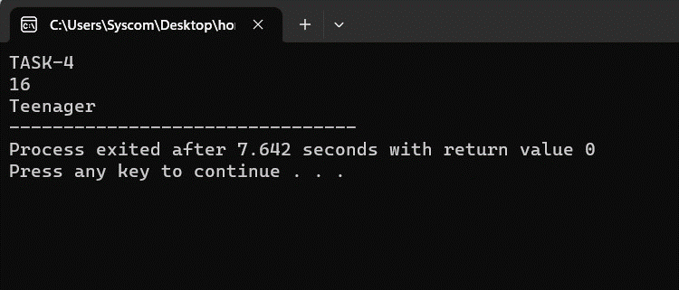

**CODE # 5:** Write a C++ program that takes three number from the user and find the greatest number out of the three numbers using nested if-else statements

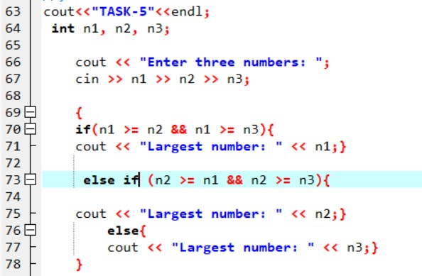

**OUTPUT:**

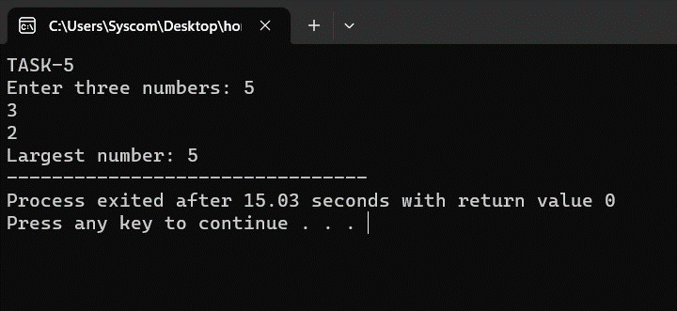

**CODE # 6:** Write a C++ program to check whether the alphabet entered by the user is Vowel or Consonant using nested if-else.

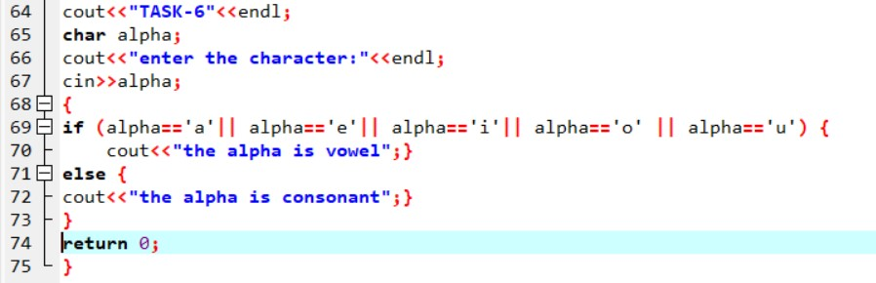

**OUTPUT:**

